$visudo --> provide admin access / network access /storage access…..
$rm -->remove file, for directory--> $rm -r //Suicide Command --> $rm -rf /
$rmdir -->delete only empty directory
Logical Volume Manager:
- Storage management:
  - File System --> EXT2,EXT3,EXT4,XFS (default),CramFS,BtrFS
  - Command to change the file System --> $mkfs.<filesystem> -->like $mkfs.xfs $mkfs.ext2….
  - Commands to managr storage in Linux
    - $du -->Display the size of directory [du -- Disk Usage]
    - $df --> List all active mounted partions
    - $fdisk -->to create, modify, delete a partition
    - $lsblk -->List all the block i.e the hard disk drives [lsblk-- List blocks]
    - $blkid -->List the unique UUID (Unique) ID of the partition
    - $mount -->It mounts the partition (temproary mount i.e untill restart)
    - /etc/fstab --> file to mount the partition permanently
    - $umount -->It unmounts the partition -- removes the partition temproarily if not listed in /etc/fstab -- if it is listed it automaticlally mounts when the system is started (in boot process)
  - Ways to add the Disk:
    - Standard partitioning -- you can add only fixed size hdd -- hard disk
    - Lvm - can be extended, its dynamic in nature
    - RAID [Redundant Array of Independent Disks]
      - RAID 0 -->stripping
      - RAID 1 -->mirroring
      - RAID 5 -->stripping with single parity
      - RAID 6 -->stripping with dual parity

Standard Partitioning : [process]
- Add a new disk to the linux system
- Create partition using fdisk utility
  - #fdisk <full disk name> --> #fdisk /dev/sdb
    - Press m --> list all the details
    - Press n --> add a new partition
    - Press p -->for primary partition
    - Press 1 -->for /dev/sdb1
    - Press enter -->1st sector -- press enter -->for last sector
    - Press w -->save and quit
- Create a file system for the partition using mkfs.xfs
- Create a mount point using mkdir cmd
- Mount the partition
  - Temproary using mount cmd
  - Permanently using /etc/fstab file
- Verify i.e $mount -a

LVM (Logical Volume Partition) : [process]
- Add a new disk to the linux system
- Create partition using fdisk utility
- Create a physical volume (PV) using Command : pvcreate
- Create a Volume group (VG) using cmd : vgcreate
- Create a logical volume (lv) using cmd : lvcreate
- Create a file system for the partition using mkfs.xfs
- Create a mount point using mkdir cmd
- Mount the partition
  - Temproary using mount cmd
  - Permanently using /etc/fstab file
- Verify i.e $mount -a
- -->Provides dynamic disk for linux os
- -->it’s a production level solution for any env
- -->with lvm we can merge multiple disk into a single logical unit

- Process:
- Physical memory (disk) -->Physical volume (pv)--> volume group(vg) --> Logical volume(lv)
Commands:
- $mkfs +tab+tab --> gives a list of all supported file systems
- $lsblk --list of blocks(disk with info of partitions)
- $fdisk /dev/sdb --path of disk

Steps to create LVM
-- add disk
--create 2 partitions of 10gb each --i.e /dev/sdb --- /dev/sdb1 /dev/sdc --- /dev/sdc1
-- create physical volume (pv)
#pvcreate /dev/sdb1 /dev/sdc1
#pvs -- show details
--create volume group (pv)
#vgcreate vg /dev/sdb1 /dev/sdc1 --(vg -- group name)
#vgs --show details
--create logical volume (lv)
# lvcreate -n lv -L +10G vg --> (lv --name, -L -- specify size of lv) or
#lvcreate -n lv -l 100%FREE vg -->(-l -- specify size in %)

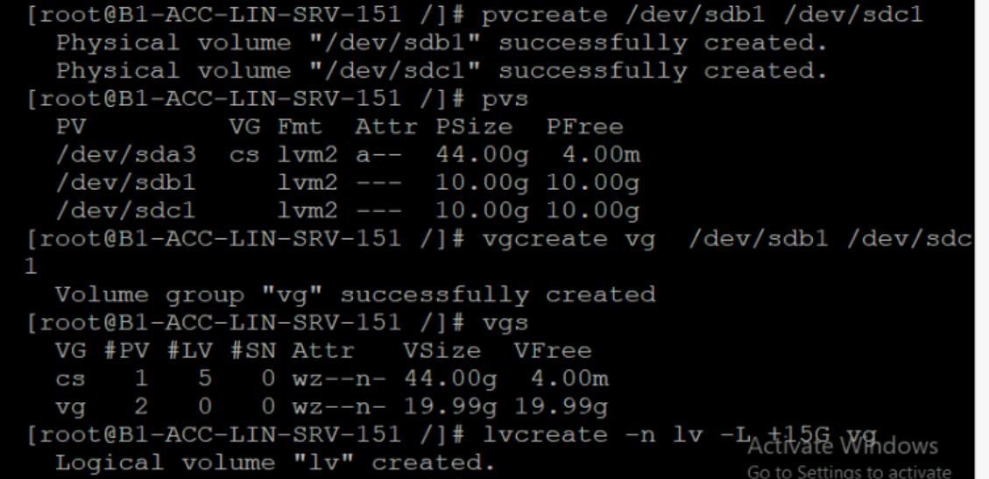

--make file system
#mkfs.ext4 /dev/vg/lv
--create mount
Create dir -- #mkdir /lvm -- name
#mount /dev/vg/lv /lvm
Verify -- > #df -h

